Reports sampling methodology to be used for Poland-Russia 2014-2020 Programme quality checks/on-the-spot control
In case there are several approved beneficiary’s reports at the time of the quality check / on-the-spot control, the CCP expert may select only one of the reports for verification.
Costs sampling methodology to be used for quality checks/on-the-spot control
- Sampling methodology
Step 1. Reviewing the list of expenditure and defining the size of the sample
The size of the sample is, as a rule, 10% of the total value of reported costs and not less than 5 expenditure included in the report ("List of expenditure"). Additionally it needs to be taken into account that the selected sample should include at least one expenditure from each budget heading accounted for real costs (considering comments included in Step 2).
Random method used for selection of expenditure is marked as "LOS" function in Excel worksheet. On the basis of the List of expenditure the range of numbers that corresponds to the number of reported expenses in a given budget heading should be specified (e.g. from 1 to 10) and from this range a number of expenditure to be verified is randomly selected. Random selection is to be done in Excel worksheet using “LOS”, with an interval or roundbeetwen.
Step 2. Additional requirements for the selection of the sampling
- Infrastructure component costs (BL 6).
All expenditure under BL6 obligatory need to be included in the scope of the sample.
Note: If the number of expenditures under the infrastructure component exceeds 5, the sample should take at least 10% of the value of expenditures under this component, taking into account not less than 5 expenditures, including at least 3 expenditures of the highest value.
- Public procurement.
Applicable for Poland: It should be checked whether the report includes expenses incurred as part of public procurement procedures pursuant to the PPL. If so, then:
  - in case of public procurement for the project (contracts carried out solely for the purposes of the project) - such procedure is obligatorily checked, and the expenditure incurred under this contract is obligatorily included in the sample of a given budget heading.
  - in case of public procurement of an institutional nature (contracts carried out for the needs of the entire institution and not only for the purposes of the project), e.g. for catering, translation services, etc. - the procedures are subject to control when the sum of expenses settled under the project exceeds PLN 4,500 gross.
Applicable for Russia:
It should be checked whether the report includes expenses incurred eligible for the competitive procedures of public procurement.
- If so, then every expenditure is the subject for the verification
- If not, then expenditures for contracts higher than 600.000,00 rubles according with the Federal Law No.44-FZ; higher than 100.000,00 rubles (500.000,00 rubles for major contracting authorities) according with the Federal Law No.223-FZ are the subjects for the verification.
Procurement for Russian Private Institutions
Every expenditure exceeding 3000 € it must be checked for compliance of the procurement procedure with the requirements of the Program Manual Part I (chapter 6.4.3.3 Specific programme rules for entities established in Russia).
- Staff costs (BL 1).
It has to be verified if BL1 includes expenses related to staff salaries that are reported for the first time and have not been previously verified:
  - If so, then one item from reported expenditure is selected using the random selection method.
  - If not, then one item from reported expenditure relating to the salaries of the staff previously inspected shall be selected using the random selection method.
If an expense that is a separate component of the employee's remuneration (e.g. tax to the Tax Office) was selected for the sample, all components of this remuneration are automatically verified.
- Other budget lines.
It should be checked whether the remaining budget lines include expenses above 5,000.00 EUR / item:
- If so, such expenditure is obligatory included in the sample.
- If not, 1 expenditure is randomly selected for the control.
Step 3. Check of the sample size.
It should be verified if the value of expenditure selected for control is equal to or greater than the specified sample size (10% of the total value of reported costs):
- If not, the expenditure to be controlled is selected randomly to the specified sample size
- If so, the next step is to be performed.
It should be checked whether the selected expenditure include accounting documents with a VAT item.
- If so, VAT eligibility should be verified.
- If not, it is to be checked whether report includes invoices with VAT. If so, no less than 3 invoices are selected for the sample. If there are less than 3, all invoices with VAT are checked.
Step 4. Verification of the sample reliability.
List of expenditure should be verified against:
- Whether the value of expenditure not selected for the sample significantly exceed the average value of expenditure of a given type included in the report and previously certified reports, e.g. sudden, disproportionate increase in the remuneration of a given member of the management team, non-market value of an invoice for a service exempt from the application of the PPL.
- Whether the sample allow for rational assurance that the remaining expenses included in the report are free from deficiencies and / or irregularities (e.g. of a nature identified during previous controls at a given beneficiary, ineligible expenses detected in previously verified reports, expenses previously / double reported).
In the event of doubts, in particular those referred to the points above, the CCP expert decides on the selection and size of the complementary expenditure based on his professional judgment (by expanding the sample or supplementing the sample with questionable expenditure). The CCP expert always has the option to expand the sample.
The sample selection is documented as in Table No. 1.
- Extending the sample
- If the controller detects any errors/irregularities in the chosen basic sample that may have an impact on other expenditures out of the sample of the same type and / or of the same nature, the CCP expert extends the sample including that expenses.
- When serious errors are detected by the CCP expert in the sample it can be extended.
By the occurrence of serious errors must be understood situations where:
- The total value of ineligible costs on the examined budget heading exceeds 5% of the total value of the project budget in the given budget heading or 1000 EUR,
- The CCP expert gained a reasonable suspicion that detected ineligible costs result from the actions incompatible with project objectives and/or do not reflect project results,
- The CCP expert gained a reasonable suspicion that detected ineligible costs result from the fraud.
- If the CCP expert detects any of the errors as descried under point 2 (they may take place jointly or separately) in a given budget line, other expenses are selected from the remaining expenses in this budget line according to the principles specified under point I, i.e. another 10% of expenses are subject to control.
- Ineligible expenditure due to arithmetic and technical errors does not lead to an extension of the sample.
The necessity to extend the sample is documented as in Table 2. It is attached to the control documentation.
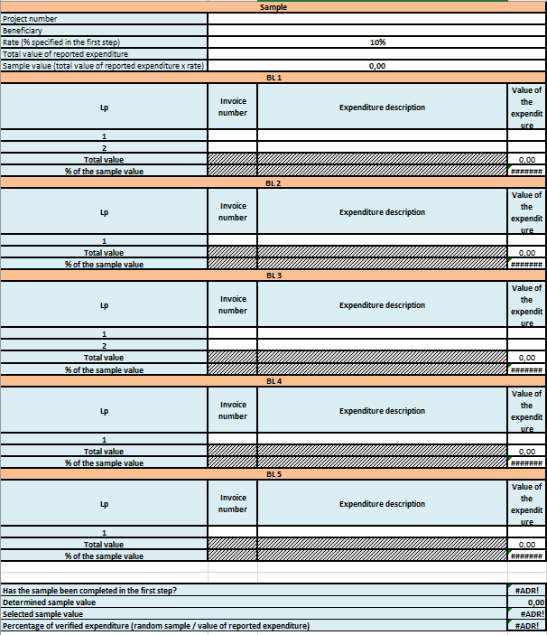
Table No 1.

Table No 2.
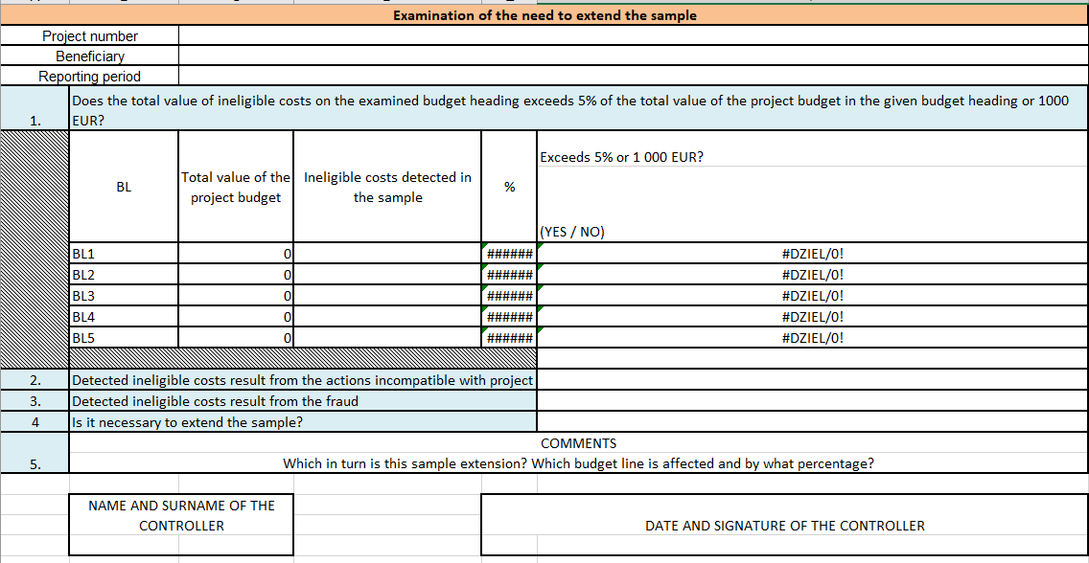

In this situation, the control sample is automatically expanded.
Not applicable for BL6.
Reasonable assurance means ensuring that the expenditure is free from deficiencies or irregularities on the basis of the examined sample; rational assurance does not mean absolute certainty.
For example: (a) travel costs for several persons related to the same trip, of which only one delegation was selected in the sample. b) contracts with a value exceeding program thresholds, in case the contract selected for inspection was not preceded by an appropriate selection procedure.

